**TTK Gameplay Assignment**

This assignment is for you to show various skills in performance, debugging and gameplay creation. Don’t see it as a “test”. It should be handled as you would handle a task working on creating a game.

You are going to create a simple tank game.

When you are done, the game should contain the following:

* It should be playable.

Right now, it is crashing and full of bugs.

* The tank should be moveable, and you should be able to shoot bullets.
* There should be enemies with health. (They don’t have to have any kind of AI)

They should have settings for how many hits they can take.

That amount should be exposed in a way so a designer can modify it.

* You should be able to shoot and kill the enemies.

(Spawning new enemies when they die is not a requirement)

* Implement something you are passionate about, related to the tank game.

(This is your time to shine and show us whatever you want)

Examples to that could be:

* Cool tank movement.
* Homing missiles.
* Bullet pooling with memory optimization.
* Predicted network shooting.

(These are just examples but feel free to pick any of these if you feel passionate about any of them)

Implementing all the above points in some manner is the minimum requirement.

Feel free to rewrite what you want if you feel that will improve the result, but be prepared to answer questions about why you changed it (or why you didn’t)

Take the time you need, but you should not overdo it.

Good luck, and most of all, enjoy and have fun!

**Unreal 5.x**

To start the test, you need to download the unreal engine using the epic game launcher

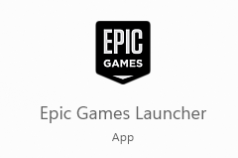

Step by step guide on how to install:

<https://www.vfxapprentice.com/blog/install-unreal-engine-quick-start#:~:text=First%20you'll%20need%20to,go%20and%20click%20on%20install>.

You can also download the source code for the engine using github but that is not required to complete the test.

If you prefer to do the test using angelscript, you are free to do that, but it is not a requirement in any way.

<https://angelscript.hazelight.se/>

And we only want the test back, not the entire engine, but let us know what version of the engine you used.

Once installed, you should be able to load the TTK gameplay test..

(You also need some kind of c++ creation tool, like visual studio, rider etc…)

If you decide to create new c++ files and they don’t show up inside your visual studio, you

can use the “generate project file”

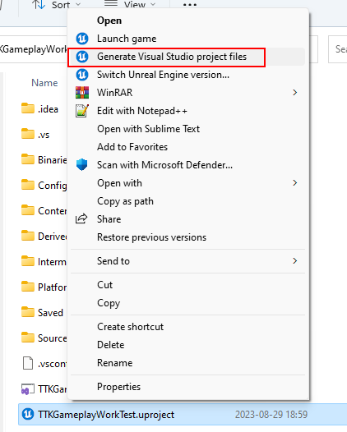

To save time during development, unreal supports “live coding.

https://docs.unrealengine.com/5.0/en-US/using-live-coding-to-recompile-unreal-engine-applications-at-runtime/

CTRL+ALT+F11 will recompile the code, without you having to close the editor.

This works best, if you are only modifying cpp body files.

OBS!

Whenever you create new UFUNCTION, UCLASS, UPROPERTY or USTRUCT macros, you should always restart the engine to avoid unnecessary bugs (that will only show up until you restart the engine)